Completely Asymmetric Shapes

Definition
# Source: AI Source: Provided by: [Data Path: Persons Table -> ID Column: 1, Name_En Column: Motasem Essam] -> From: [ChatGPT] on [7/25/2026]
Completely Asymmetric Shapes are shapes that have no non-trivial symmetry under the symmetry transformations being considered.
In the standard geometric sense, a completely asymmetric shape has:
- no reflection symmetry,
- no non-trivial rotational symmetry,
- no point symmetry,
- and no other relevant self-mapping symmetry.
In other words, the shape cannot be transformed into itself by a non-trivial symmetry operation.
$$\boxed{T\left(S\right)≠S}$$
for every relevant non-identity symmetry transformation $T$.
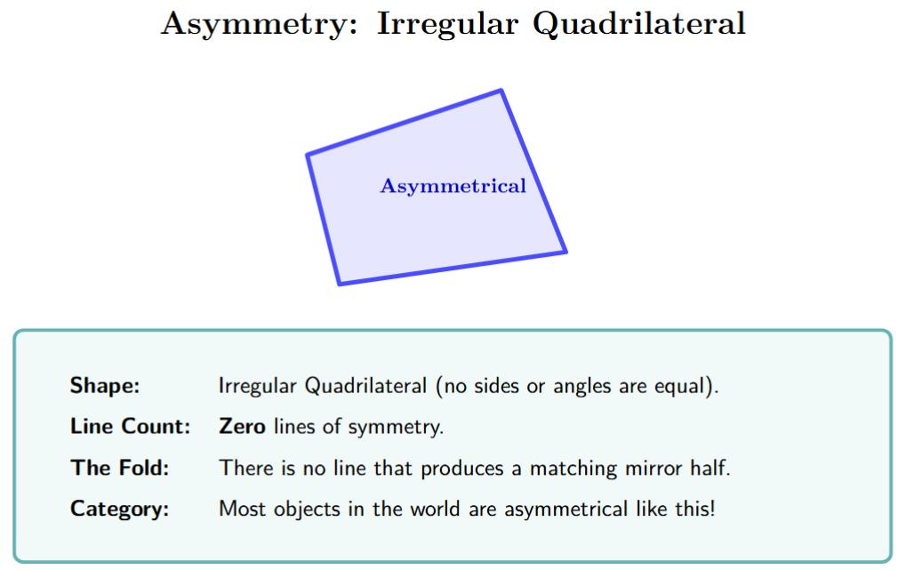
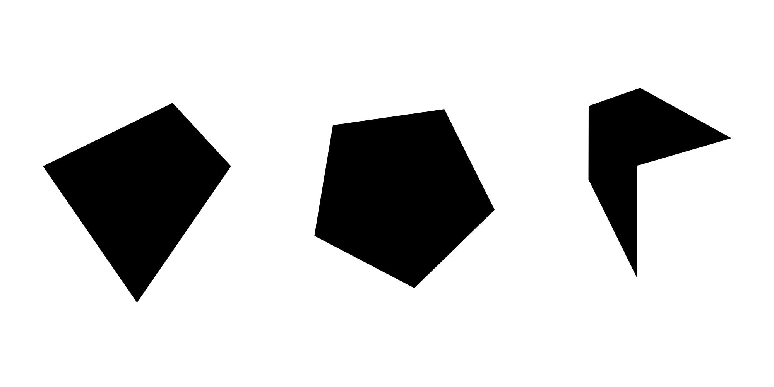
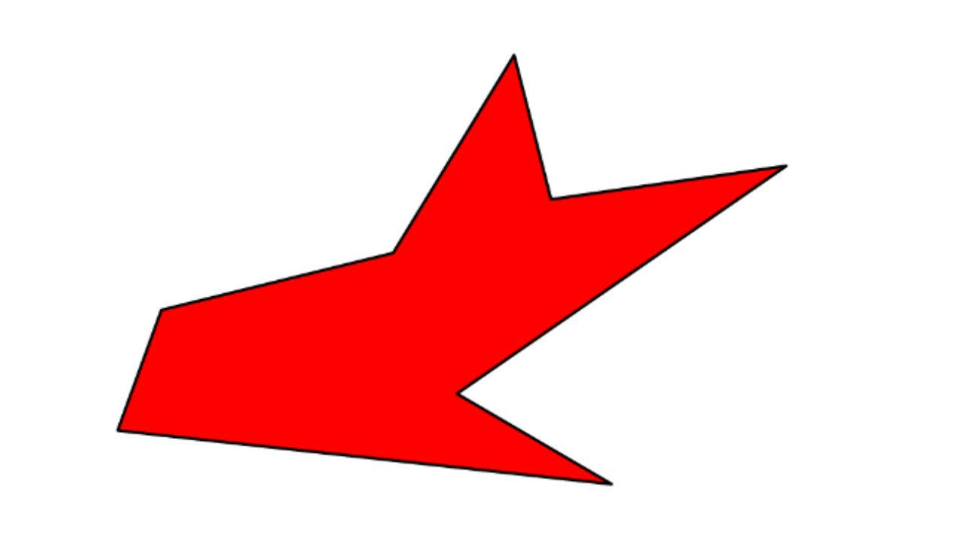
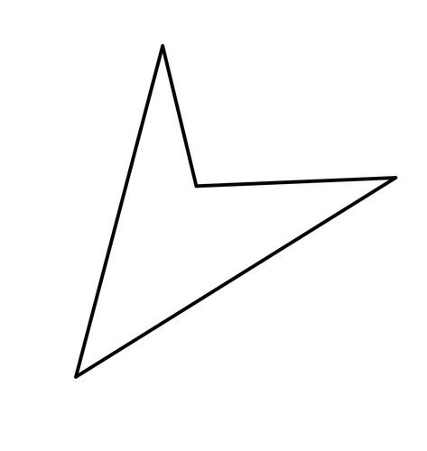
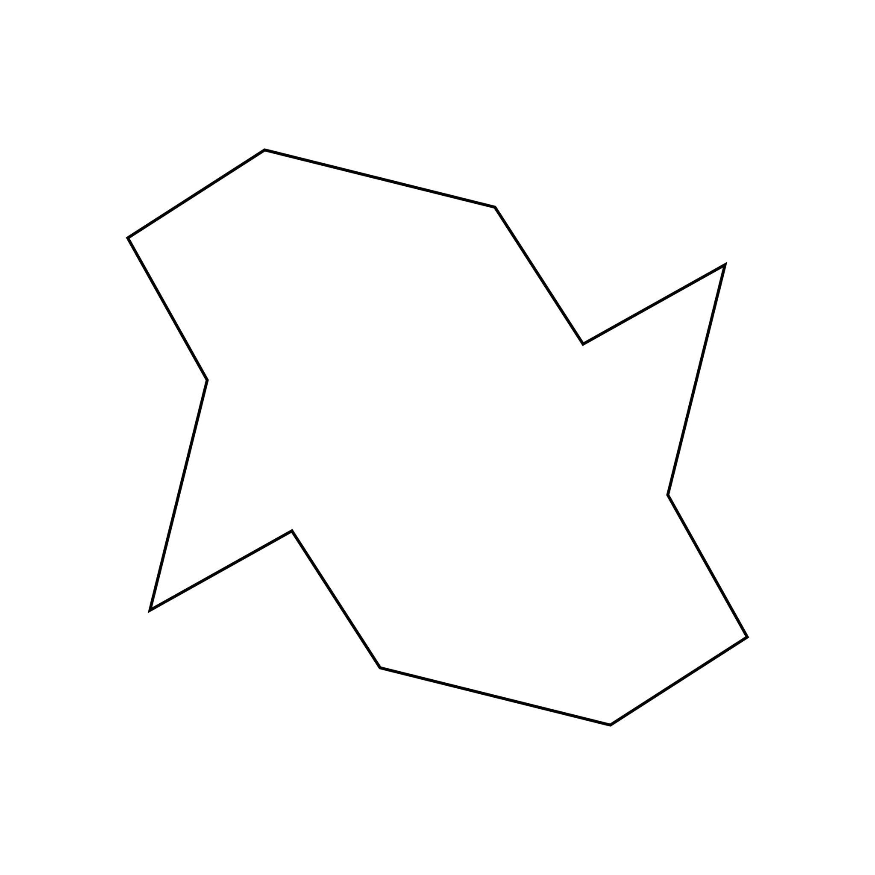

Fundamental Concept
# Source: AI Source: Provided by: [Data Path: Persons Table -> ID Column: 1, Name_En Column: Motasem Essam] -> From: [ChatGPT] on [7/25/2026]
A shape can be asymmetric in one particular way without being asymmetric in every way.
For example:
- A shape may have reflection symmetry but no rotational symmetry.
- A shape may have rotational symmetry but no reflection symmetry.
- A shape may have point symmetry but no reflection symmetry.
A completely asymmetric shape goes further: it has none of the relevant non-trivial symmetries.
Therefore:
$$\boxed{\text{Completely Asymmetric}⇒\text{No Relevant Non-Trivial Symmetry}}$$
This makes complete asymmetry a broader condition than a single type such as reflection-asymmetry or rotation-asymmetry.

Mathematical Definition
# Source: AI Source: Provided by: [Data Path: Persons Table -> ID Column: 1, Name_En Column: Motasem Essam] -> From: [ChatGPT] on [7/25/2026]
Let $S$be a shape and let $G$represent the set of geometric symmetry transformations being considered.
A shape is completely asymmetric if:
$$\boxed{T\left(S\right)≠S \text{for every }T∈G, T≠I}$$
where:
- $T$= a transformation,
- $S$= the shape,
- $I$= the identity transformation.
The identity transformation is excluded because it leaves every shape unchanged.

Main Symmetries That Must Be Absent
# Source: AI Source: Provided by: [Data Path: Persons Table -> ID Column: 1, Name_En Column: Motasem Essam] -> From: [ChatGPT] on [7/25/2026]
For ordinary planar shapes, complete asymmetry commonly means the absence of:
1. Reflection symmetry
No line reflects the shape onto itself.
$$R\left(S\right)≠S$$
2. Rotational symmetry
No rotation through an angle
$$0^{∘}<θ<{360}^{∘}$$
maps the shape onto itself.
$$R_{O,θ}\left(S\right)≠S$$
3. Point symmetry
No ${180}^{∘}$rotation about a center maps the shape onto itself.
$$R_{O,{180}^{∘}}\left(S\right)≠S$$
Point symmetry is a special case of rotational symmetry.

Types of Completely Asymmetric Shapes
# Source: AI Source: Provided by: [Data Path: Persons Table -> ID Column: 1, Name_En Column: Motasem Essam] -> From: [ChatGPT] on [7/25/2026]
A useful classification is:
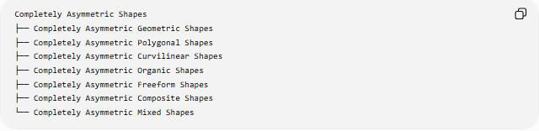
Completely Asymmetric Shapes
├── Completely Asymmetric Geometric Shapes
├── Completely Asymmetric Polygonal Shapes
├── Completely Asymmetric Curvilinear Shapes
├── Completely Asymmetric Organic Shapes
├── Completely Asymmetric Freeform Shapes
├── Completely Asymmetric Composite Shapes
└── Completely Asymmetric Mixed Shapes
These categories describe the form of the shape, while "completely asymmetric" describes its symmetry properties.

Completely Asymmetric Geometric Shapes
# Source: AI Source: Provided by: [Data Path: Persons Table -> ID Column: 1, Name_En Column: Motasem Essam] -> From: [ChatGPT] on [7/25/2026]
These are geometric shapes that possess no relevant non-trivial symmetry.
Typical examples include specially constructed irregular polygons whose sides, angles, and vertex positions are arranged without any repeating symmetry.
For example, an irregular polygon may have:
- different side lengths,
- different angles,
- uneven vertex placement,
- no reflection axis,
- no rotational symmetry.
Such a shape can be completely asymmetric.

Completely Asymmetric Polygonal Shapes
# Source: AI Source: Provided by: [Data Path: Persons Table -> ID Column: 1, Name_En Column: Motasem Essam] -> From: [ChatGPT] on [7/25/2026]
A polygon is completely asymmetric when its entire arrangement of vertices and edges has no non-trivial symmetry.
Common examples
- Many scalene triangles
- Generic irregular quadrilaterals
- Generic irregular pentagons
- Generic irregular polygons
- Irregular concave polygons
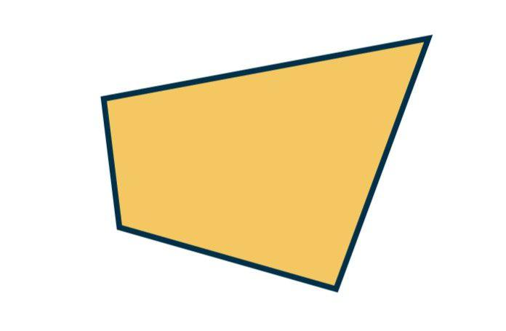
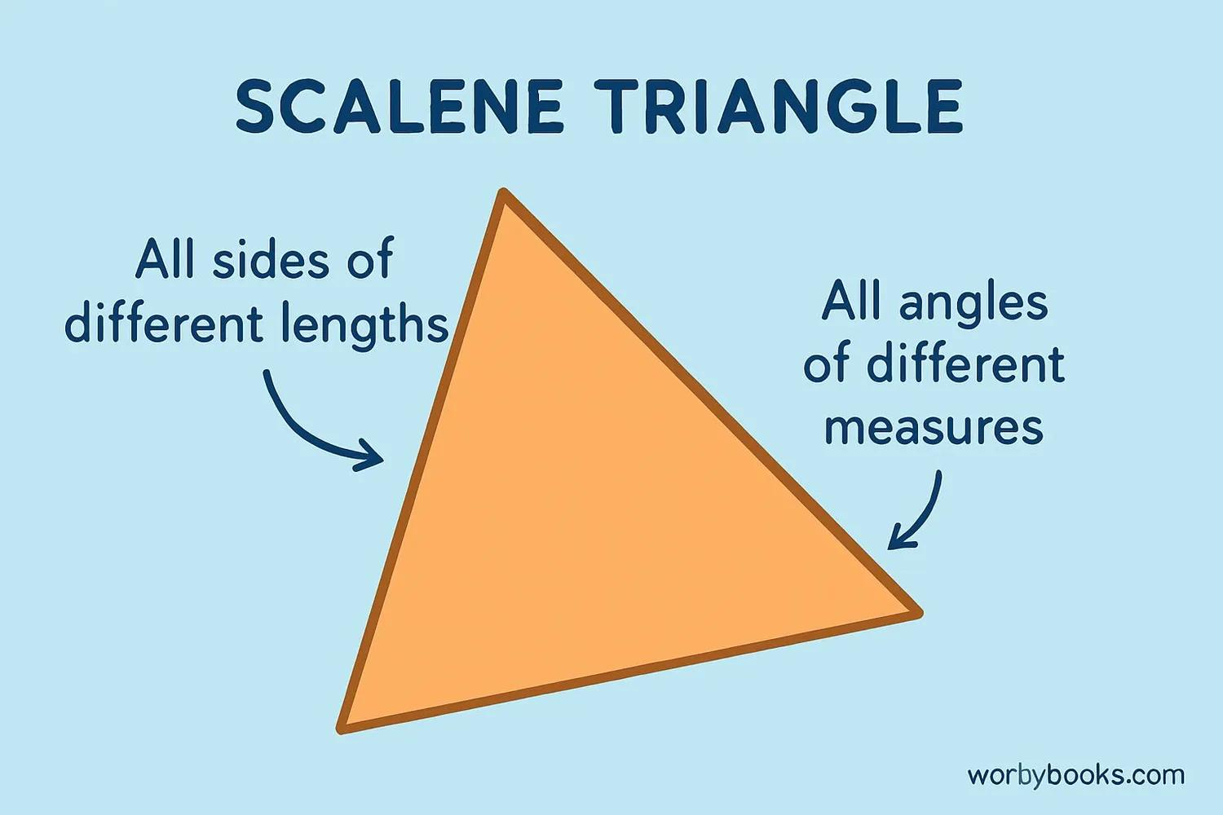
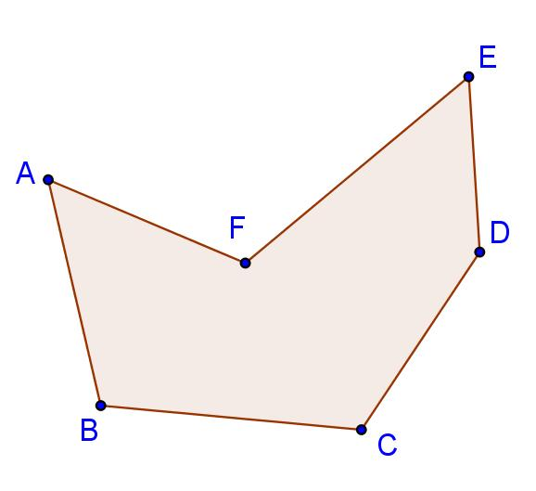
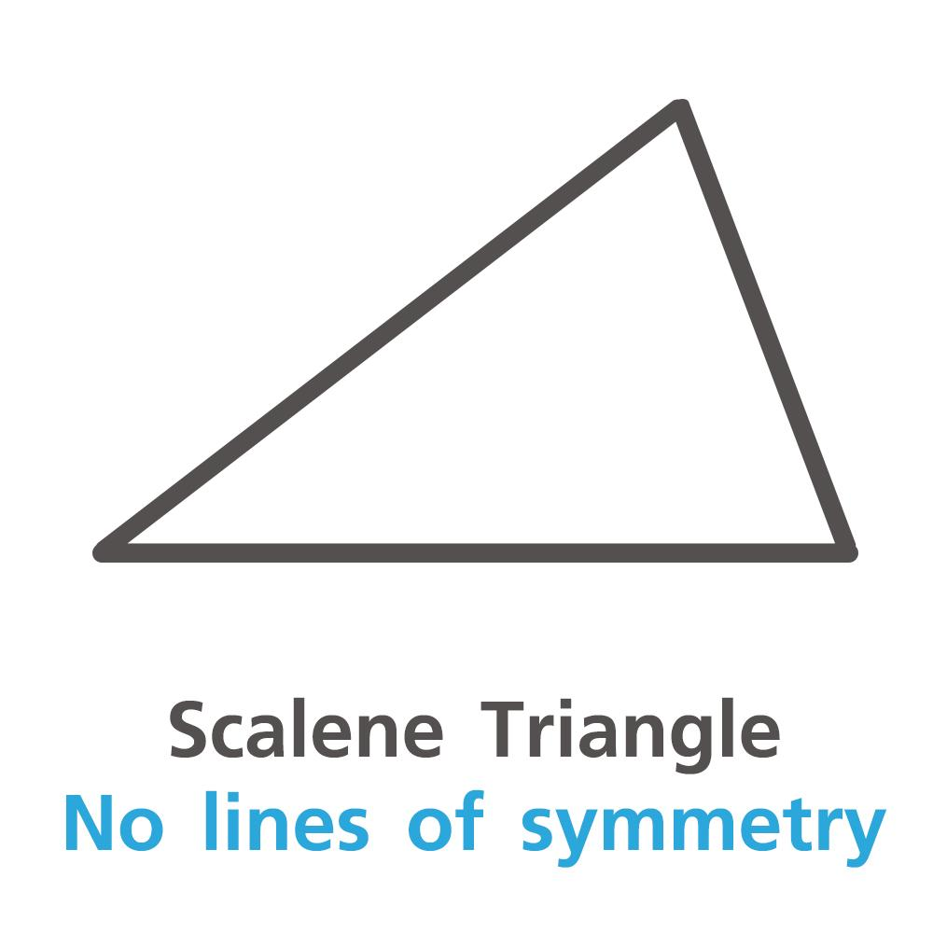
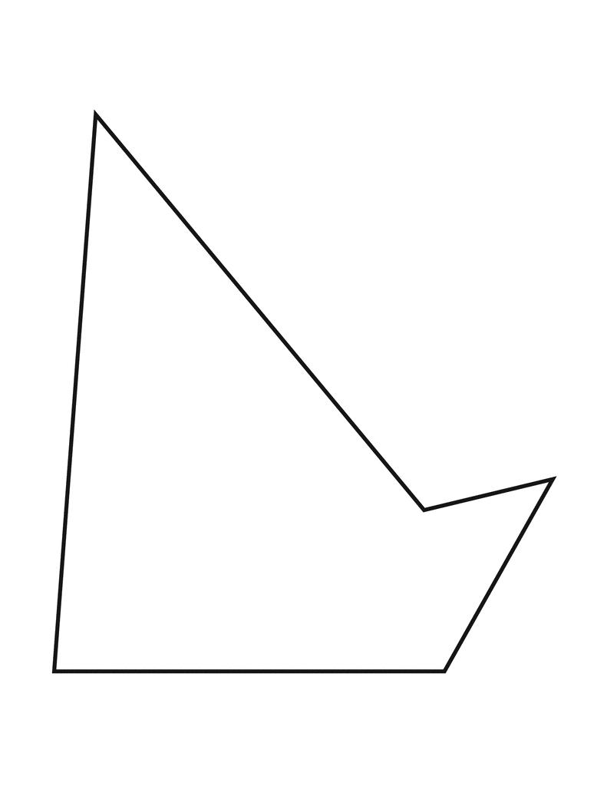
Important example: scalene triangle
A scalene triangle has:
- no reflection symmetry,
- no non-trivial rotational symmetry,
- no point symmetry.
Therefore, it is a simple example of a completely asymmetric polygon.
$$\boxed{\text{Scalene triangle }\text{→} \text{completely} \text{asymmetric}}$$

Completely Asymmetric Curvilinear Shapes
# Source: AI Source: Provided by: [Data Path: Persons Table -> ID Column: 1, Name_En Column: Motasem Essam] -> From: [ChatGPT] on [7/25/2026]
These are shapes whose curved boundaries have no relevant symmetry.
Examples include:
- Irregular curved regions
- Uneven freeform curves
- Asymmetric combinations of arcs
- Irregular curved boundaries
A curve may be smooth but still completely asymmetric.
For example, smoothness does not create symmetry:
$$\boxed{\text{Smooth}≠\text{Symmetric}}$$

Completely Asymmetric Organic Shapes
# Source: AI Source: Provided by: [Data Path: Persons Table -> ID Column: 1, Name_En Column: Motasem Essam] -> From: [ChatGPT] on [7/25/2026]
Organic shapes often have irregular forms, but organic does not automatically mean completely asymmetric.
A completely asymmetric organic shape has no relevant reflection, rotational, or point symmetry.
Examples may include:
- Uneven natural forms
- Irregular leaf-like forms
- Asymmetric rock-like outlines
- Irregular biological forms
- Uneven flowing forms
The important property is the absence of symmetry, not simply the natural appearance.

Completely Asymmetric Freeform Shapes
# Source: AI Source: Provided by: [Data Path: Persons Table -> ID Column: 1, Name_En Column: Motasem Essam] -> From: [ChatGPT] on [7/25/2026]
A freeform shape has no fixed standard geometric structure.
A freeform shape becomes completely asymmetric when its structure also lacks all relevant non-trivial symmetries.
Therefore:
$$\boxed{\text{Freeform}≠\text{Completely Asymmetric}}$$
A freeform shape can still have:
- reflection symmetry,
- rotational symmetry,
- point symmetry.
For example, a freeform shape can be deliberately designed with bilateral symmetry.

Completely Asymmetric Composite Shapes
# Source: AI Source: Provided by: [Data Path: Persons Table -> ID Column: 1, Name_En Column: Motasem Essam] -> From: [ChatGPT] on [7/25/2026]
A composite shape consists of multiple components.
It is completely asymmetric when the arrangement of all components has no non-trivial symmetry.
For example:
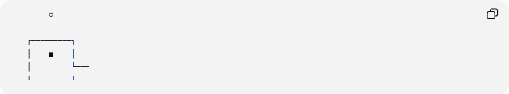
○

┌─────────┐
│ ■ │
│ └───
└─────────┘
The individual components may themselves be symmetric, but their overall arrangement may not be.
This is an important principle:
$$\boxed{\text{Symmetric components}⇏\text{Symmetric composite}}$$

Completely Asymmetric Mixed Shapes
# Source: AI Source: Provided by: [Data Path: Persons Table -> ID Column: 1, Name_En Column: Motasem Essam] -> From: [ChatGPT] on [7/25/2026]
Mixed shapes combine different geometric elements.
They may contain:
- Straight lines
- Circular arcs
- Elliptical arcs
- Freeform curves
- Organic components
- Multiple regions
If the entire arrangement lacks all relevant non-trivial symmetry, it is completely asymmetric.
For example:
$$\text{circle}+\text{irregular polygon}+\text{freeform curve}$$
may form a completely asymmetric mixed shape.

Completely Asymmetric vs Reflection-Asymmetric
# Source: AI Source: Provided by: [Data Path: Persons Table -> ID Column: 1, Name_En Column: Motasem Essam] -> From: [ChatGPT] on [7/25/2026]
These are not equivalent.
Reflection-asymmetric
A shape lacks reflection symmetry.
Completely asymmetric
A shape lacks reflection symmetry and the other relevant non-trivial symmetries.
Therefore:
$$\boxed{\text{Completely asymmetric}⇒\text{Reflection-asymmetric}}$$
but:
$$\boxed{\text{Reflection-asymmetric}⇏\text{Completely asymmetric}}$$
Example
A regular pentagon has reflection symmetry, so it is not reflection-asymmetric.
But consider a shape with rotational symmetry of order $3$and no reflection symmetry. It is reflection-asymmetric but not completely asymmetric because it still has rotational symmetry.

Completely Asymmetric vs Rotation-Asymmetric
# Source: AI Source: Provided by: [Data Path: Persons Table -> ID Column: 1, Name_En Column: Motasem Essam] -> From: [ChatGPT] on [7/25/2026]
Rotation-asymmetric
No non-trivial rotation maps the shape onto itself.
Completely asymmetric
No relevant non-trivial symmetry transformation maps the shape onto itself.
Therefore:
$$\boxed{\text{Completely asymmetric}⇒\text{Rotation-asymmetric}}$$
But:
$$\boxed{\text{Rotation-asymmetric}⇏\text{Completely asymmetric}}$$
because a rotation-asymmetric shape may still have reflection symmetry.
Example
An isosceles triangle has:
- reflection symmetry,
- no non-trivial rotational symmetry.
Therefore it is rotation-asymmetric but not completely asymmetric.

Completely Asymmetric vs Point-Asymmetric
# Source: AI Source: Provided by: [Data Path: Persons Table -> ID Column: 1, Name_En Column: Motasem Essam] -> From: [ChatGPT] on [7/25/2026]
Point symmetry is ${180}^{∘}$rotational symmetry.
Therefore:
$$\boxed{\text{Completely asymmetric}⇒\text{Point-asymmetric}}$$
But the reverse is not necessarily true.
A regular triangle is point-asymmetric because it has no ${180}^{∘}$rotational symmetry, but it has ${120}^{∘}$rotational symmetry.
Thus:
$$\boxed{\text{Point-asymmetric}⇏\text{Completely asymmetric}}$$

Completely Asymmetric vs Irregular
# Source: AI Source: Provided by: [Data Path: Persons Table -> ID Column: 1, Name_En Column: Motasem Essam] -> From: [ChatGPT] on [7/25/2026]
These concepts are fundamentally different.
Irregular
Describes whether a shape follows the conditions of a regular geometric form.
Completely asymmetric
Describes the absence of symmetry.
Therefore:
$$\boxed{\text{Irregular}≠\text{Completely Asymmetric}}$$
An irregular rectangle, for example, is still a rectangle and has ${180}^{∘}$rotational symmetry.
A completely asymmetric shape does not necessarily need to be described simply as "irregular"; complete asymmetry is a statement about transformations.

Completely Asymmetric vs Freeform
# Source: AI Source: Provided by: [Data Path: Persons Table -> ID Column: 1, Name_En Column: Motasem Essam] -> From: [ChatGPT] on [7/25/2026]
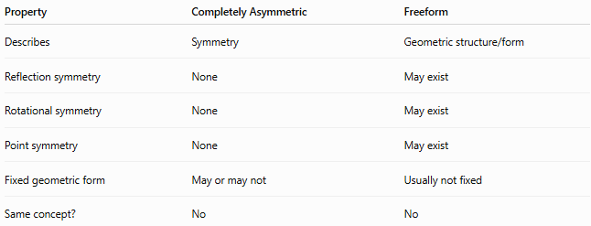
Property | Completely Asymmetric | Freeform
Describes | Symmetry | Geometric structure/form
Reflection symmetry | None | May exist
Rotational symmetry | None | May exist
Point symmetry | None | May exist
Fixed geometric form | May or may not | Usually not fixed
Same concept? | No | No
Thus:
$$\boxed{\text{Freeform}≠\text{Completely Asymmetric}}$$

Mathematical Test for Complete Asymmetry
# Source: AI Source: Provided by: [Data Path: Persons Table -> ID Column: 1, Name_En Column: Motasem Essam] -> From: [ChatGPT] on [7/25/2026]
For a planar shape $S$, test the relevant transformations individually.
Reflection
For every possible reflection axis:
$$\boxed{R\left(S\right)≠S}$$
Rotation
For every non-trivial rotation:
$$\boxed{R_{O,θ}\left(S\right)≠S}$$
where:
$$0^{∘}<θ<{360}^{∘}$$
Point symmetry
In particular:
$$\boxed{R_{O,{180}^{∘}}\left(S\right)≠S}$$
If none of the relevant transformations preserve the shape, it is completely asymmetric.

Coordinate Transformation
# Source: AI Source: Provided by: [Data Path: Persons Table -> ID Column: 1, Name_En Column: Motasem Essam] -> From: [ChatGPT] on [7/25/2026]
For rotation about the origin:
$$\boxed{\begin{aligned}x^{'}&=x\cos{θ}-y\sin{θ} \\ y^{'}&=x\sin{θ}+y\cos{θ}\end{aligned}}$$
A shape has rotational symmetry only if this transformation reproduces the entire shape for some non-zero angle less than ${360}^{∘}$.
For reflection across the $y$-axis:
$$\boxed{\left(x , y\right)→\left(- , xy\right)}$$
For reflection across the $x$-axis:
$$\boxed{\left(x , y\right)→\left(x , -y\right)}$$
A completely asymmetric shape fails all relevant symmetry tests.

Examples

Example 1 — Scalene Triangle
# Source: AI Source: Provided by: [Data Path: Persons Table -> ID Column: 1, Name_En Column: Motasem Essam] -> From: [ChatGPT] on [7/25/2026]
A scalene triangle has:
- No equal sides
- No reflection axis
- No non-trivial rotational symmetry
- No point symmetry
Therefore:
$$\boxed{\text{Scalene triangle }\text{→} \text{completely} \text{asymmetric}}$$

Example 2 — Isosceles Triangle
# Source: AI Source: Provided by: [Data Path: Persons Table -> ID Column: 1, Name_En Column: Motasem Essam] -> From: [ChatGPT] on [7/25/2026]
An isosceles triangle has one reflection axis.
Therefore it is not completely asymmetric.
It is reflection-symmetric even though it lacks non-trivial rotational symmetry.

Example 3 — Equilateral Triangle
# Source: AI Source: Provided by: [Data Path: Persons Table -> ID Column: 1, Name_En Column: Motasem Essam] -> From: [ChatGPT] on [7/25/2026]
An equilateral triangle has:
- 3 reflection axes
- Rotational symmetry of order $3$
Therefore it is not completely asymmetric.

Example 4 — Rectangle
# Source: AI Source: Provided by: [Data Path: Persons Table -> ID Column: 1, Name_En Column: Motasem Essam] -> From: [ChatGPT] on [7/25/2026]
A rectangle has:
- 2 reflection axes
- ${180}^{∘}$rotational symmetry
Therefore it is not completely asymmetric.

Example 5 — Generic Irregular Polygon
# Source: AI Source: Provided by: [Data Path: Persons Table -> ID Column: 1, Name_En Column: Motasem Essam] -> From: [ChatGPT] on [7/25/2026]
Consider a polygon with unequal and unevenly arranged sides and angles, with no repeating structure.
If it has:
- no reflection symmetry,
- no rotational symmetry,
- no point symmetry,
then:
$$\boxed{\text{It is completely asymmetric}}$$

Classification Summary
# Source: AI Source: Provided by: [Data Path: Persons Table -> ID Column: 1, Name_En Column: Motasem Essam] -> From: [ChatGPT] on [7/25/2026]
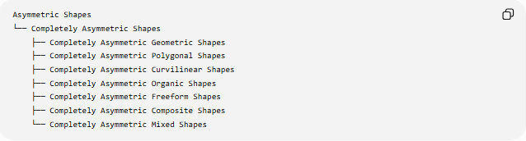
Asymmetric Shapes
└── Completely Asymmetric Shapes
├── Completely Asymmetric Geometric Shapes
├── Completely Asymmetric Polygonal Shapes
├── Completely Asymmetric Curvilinear Shapes
├── Completely Asymmetric Organic Shapes
├── Completely Asymmetric Freeform Shapes
├── Completely Asymmetric Composite Shapes
└── Completely Asymmetric Mixed Shapes
Transformation-based classification
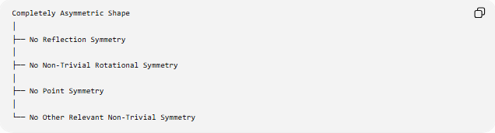
Completely Asymmetric Shape
│
├── No Reflection Symmetry
│
├── No Non-Trivial Rotational Symmetry
│
├── No Point Symmetry
│
└── No Other Relevant Non-Trivial Symmetry

Symmetry Comparison
# Source: AI Source: Provided by: [Data Path: Persons Table -> ID Column: 1, Name_En Column: Motasem Essam] -> From: [ChatGPT] on [7/25/2026]
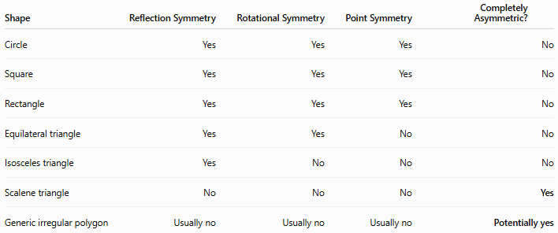
Shape | Reflection Symmetry | Rotational Symmetry | Point Symmetry | Completely Asymmetric?
Circle | Yes | Yes | Yes | No
Square | Yes | Yes | Yes | No
Rectangle | Yes | Yes | Yes | No
Equilateral triangle | Yes | Yes | No | No
Isosceles triangle | Yes | No | No | No
Scalene triangle | No | No | No | Yes
Generic irregular polygon | Usually no | Usually no | Usually no | Potentially yes
"Generic irregular polygon" is only completely asymmetric if its actual geometry has no non-trivial symmetry.

Relationship with Other Asymmetric Types
# Source: AI Source: Provided by: [Data Path: Persons Table -> ID Column: 1, Name_En Column: Motasem Essam] -> From: [ChatGPT] on [7/25/2026]
The hierarchy can be understood as:
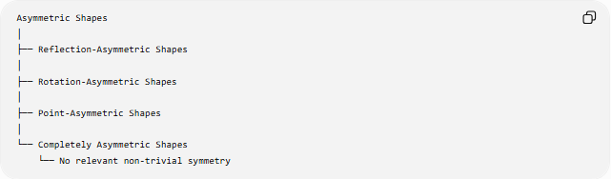
Asymmetric Shapes
│
├── Reflection-Asymmetric Shapes
│
├── Rotation-Asymmetric Shapes
│
├── Point-Asymmetric Shapes
│
└── Completely Asymmetric Shapes
└── No relevant non-trivial symmetry
The first three describe specific types of symmetry that are absent.
Completely asymmetric describes a shape for which all relevant non-trivial symmetry is absent.

Key Points
# Source: AI Source: Provided by: [Data Path: Persons Table -> ID Column: 1, Name_En Column: Motasem Essam] -> From: [ChatGPT] on [7/25/2026]
- Completely asymmetric shapes have no relevant non-trivial symmetry.
- They have no reflection symmetry.
- They have no non-trivial rotational symmetry.
- They have no point symmetry.
- Point symmetry is already included within rotational symmetry because it corresponds to a ${180}^{∘}$rotation.
- Completely asymmetric is stronger than being merely reflection-asymmetric, rotation-asymmetric, or point-asymmetric.
- Irregularity does not automatically mean complete asymmetry.
- Freeform does not automatically mean complete asymmetry.
- Organic does not automatically mean complete asymmetry.
- A symmetric component can be part of a completely asymmetric composite arrangement.
- A scalene triangle is a simple example of a completely asymmetric shape.
- Complete asymmetry is best understood as a property of transformations, not simply as a visual impression.

